1. SP- Claims to be replaced with SP – Service Request. Add service request **#DONE(Fixed)**

Field name to be changed as GST %, IGST Amt, SGST Amt, CGST Amt Should be capital letters. **#DONE (Fixed)**

2) Field name **Actual Cost Including Tax** to be changed to **(Actual cost Including GST)** should be placed next to HSN/SAC. Should be freezed it should not change.**#DONE (Fixed)**

1. Cost to be changed as **Per Unit/ Qty cost (Excl Tax**) fields should be blank dealer to fill **#DONE (Fixed)**, the end Mrp price should not exceed Actual cost Including tax**(Fixed)**
2. Total **Cost** to be **MRP #DONE (Fixed)**
3. 14.Kindly change TVS TWG to ASSURANT**#DONE(Fixed)**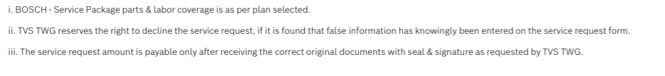
4. Upload Digital Tax invoice**#DONE (Fixed)**



1. This should not be auto tick dealer should click on it based on the parts or labour availed during service**.(Fixed)**

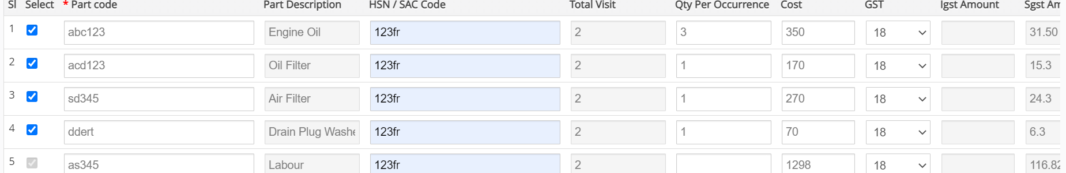

1. Labour it should not calculate based on unit value, Amt should be editable it should not cross Actual cost**(Fixed)**

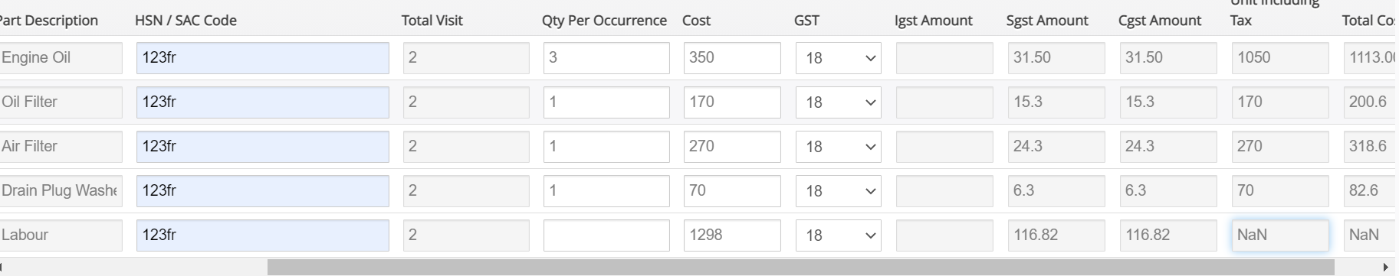

1. If a Service Request is punched amendment should not be done on Price information, warranty information or others. Only customer information or Vehicle information should be editable in which plan type should be freezed. Remove Warranty information, Price information ,other option.**(Fixed)**

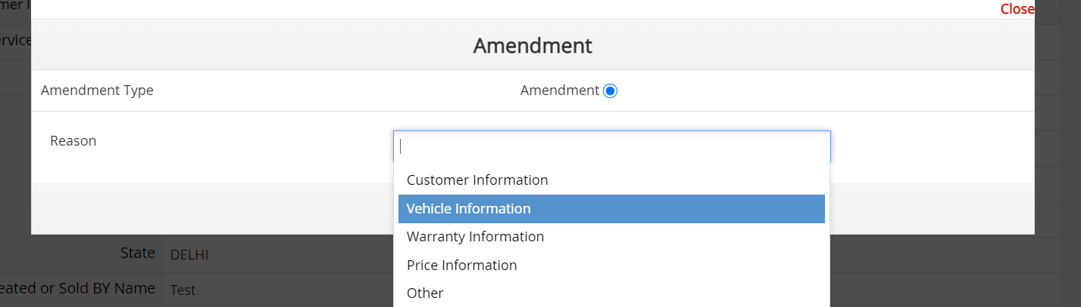

1. Payment details cannot be uploaded in portal in Admin login**.(Fixed)**

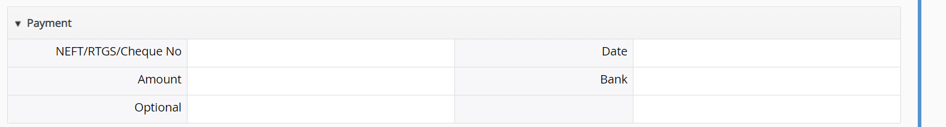

1. Portal should not accept current Odometer less than start kms. **##DONE (Fixed)**
2. Date of Job card should be same as plan punched date or greater than that**.(Fixed)**
3. SO15986 Job card no should be Min 7 Characters or max 11 alphanumeric**.(Fixed)**

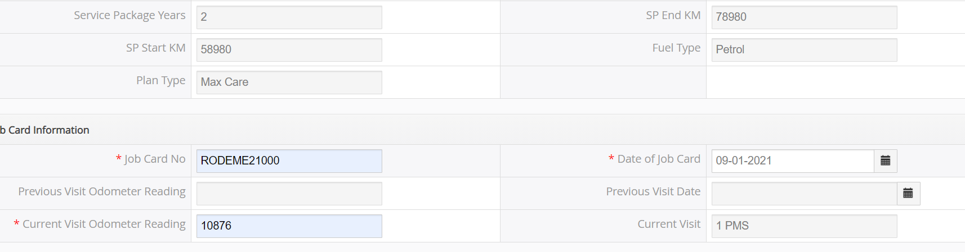

**18 jan 2021**

1. Once all the services are availed portal should Expire the Policy, based on services availed, End kms or agreement Expire date**.(Not Fixed-**Based on Odometer availed)

**After avail the odometer policy is not getting expired(ref; policy number-BSP207133)**

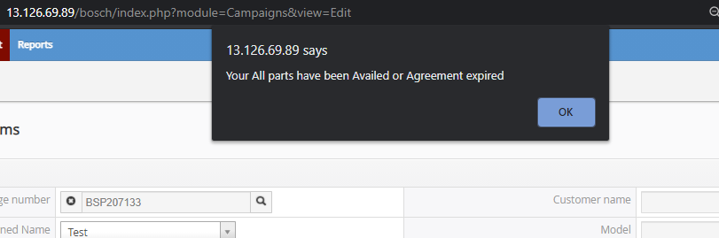

1. In claim form the grid should be with appropriate Tax break up, Correct the field placement as discussed in claim form. **(Fixed)** 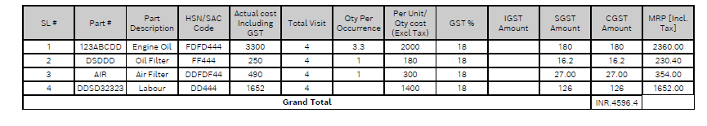

**15. GST is not as per the Master shared**

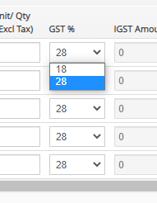

* Claim manager is not able to add **Drain Plug Washer** while Editing**(Fixed)**
* While editing any claim all the GST % line items showing 28% by defualt which is wrong.   
  ex if user selected 28% as gst then system changes it to 18% on editing (Fixed)